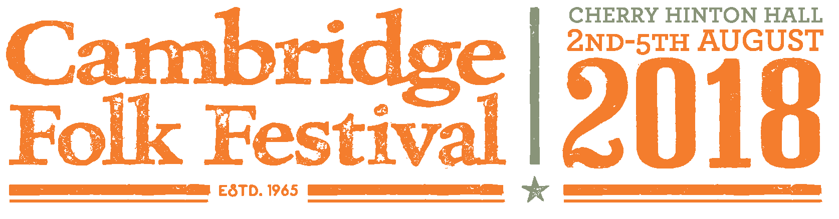

WELCOMES CAMPERS AND VISITORS!

Recycling and Waste

We are proud to be a green festival. Please help us recycle as much as possible on site.

All rubbish in Arena and on campsites is to be segregated into Mixed Recycling and General Waste. All bins will be clearly marked.

On the Camping Sites:

- **CLEAR BAG = MIXED RECYCLING ONLY **

All plastic bottles, containers and pots; plastic bags; film; cardboard; paper; newspaper; metal tins; empty aerosols; foil; cartons; glass.

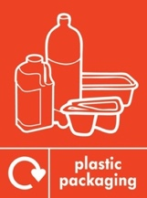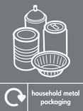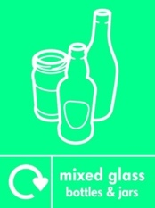

- ** RED/BLACK BAG = GENERAL WASTE ONLY**

Food waste, crisp packets, used napkins, other waste. Please consider your waste and aim to minimise food waste.
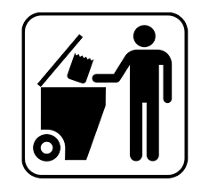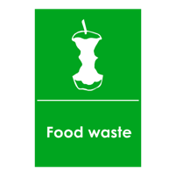

Please tie your bags with a double knot!

RECYCLING BAGS You will be given a clear mixed recycling bag and a red or black bag for waste. Extra bags can be collected from Camping Control or the Recycling Compounds.
BATTERIES There will be battery bins at recycling compounds.
DISPOSAL Once your bags are full please take to a Recycling Compound in the campsite.
MAIN ARENA Bins are always in pairs – mixed recycling and waste. Please separate waste as directed. Food remains and packaging from on-site caterers should be placed in the Waste bin. They are all biodegradable.
REUSE WATER BOTTLES AND COFFEE CUPS Please reduce plastic waste by bringing your own water bottles and refilling from the numerous taps around the site and arena. Please also bring your own reusable coffee cups.
LEAVE NO TRACE! Please do not leave any broken or unwanted tents, camping chairs or other equipment. Please continue to recycle all the final rubbish when you leave and place all bin bags in compounds. Thank you for respecting the parklands and wildlife.

Thank you for your help. Have a fantastic Folk Festival!

